Senior Meals February Lunch Menu 2023
Sunday | Monday | Tuesday | Wednesday | Thursday | Friday | Saturday
 |  |  | 1 | 2 | 3 | 4
This Photo by Unknown Author is licensed under CC BY-SA-NC | 1% Milk Available at lunch time | Menu subject to change without notice. | Corn Chowder, tossed salad, bread, & fruit | Kielbasa w/peppers, brown rice, spinach, & fruit | Take home meal  Chicken Patty Sandwich, potato chips, celery sticks & fruit | This Photo by Unknown Author is licensed under CC BY-NC
5 | 6 | 7 | 8 | 9 | 10 | 11
 | Cheeseburger Deluxe, tater tots, broccoli salad, & fruit | Minestrone Soup, tossed salad, bread, & fruit | Pulled Pork, pasta w/alfredo sauce, cauliflower, & fruit | Oven baked scrambled eggs, sausage, baked beans, & yogurt | Take home meal  Chili, cornbread, Cole slaw, & fruit | This Photo by Unknown Author is licensed under CC BY
12 | 13 | Valentine’s Day 14 | 15 | 16 | 17 | 18
This Photo by Unknown Author is licensed under CC BY-NC | Baked Chicken, mashed potatoes, cranberry sauce, squash, & fruit | Pork Chops, mashed potatoes, green bean casserole & dessert | Toasted Cheese, tomato soup& fruit | Shepherds Pie, green beans & fruit | Take home Meal  Baked Beans, Hot Dogs, Cole Slaw, & fruit | This Photo by Unknown Author is licensed under CC BY-NC-ND
19 | Washington Bday 20 | 21 | 22 | 23 | 24 | 25
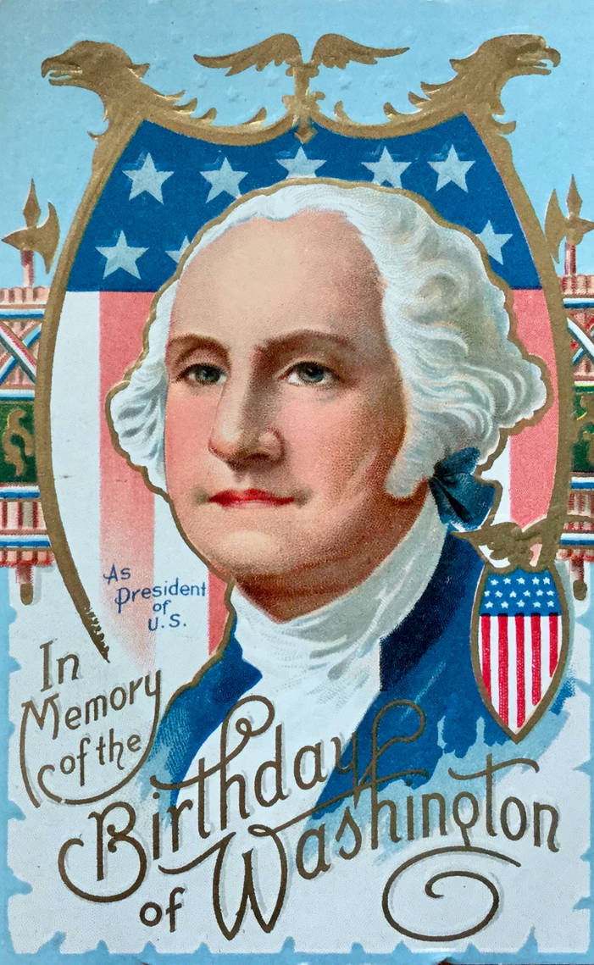  This Photo by Unknown Author is licensed under CC BY | Closed for the observance of Washington’s Birthday | Tuna Noodle casserole, pickled beets, & fruit | Baked Macaroni & cheese, hot dog, stewed tomatoes, peas, & fruit | Taco Salad, bread, & fruit | Take home Meal  Haddock Bites, French fries, corn, & fruit | This Photo by Unknown Author is licensed under CC BY-NC
26 | 27 | 28
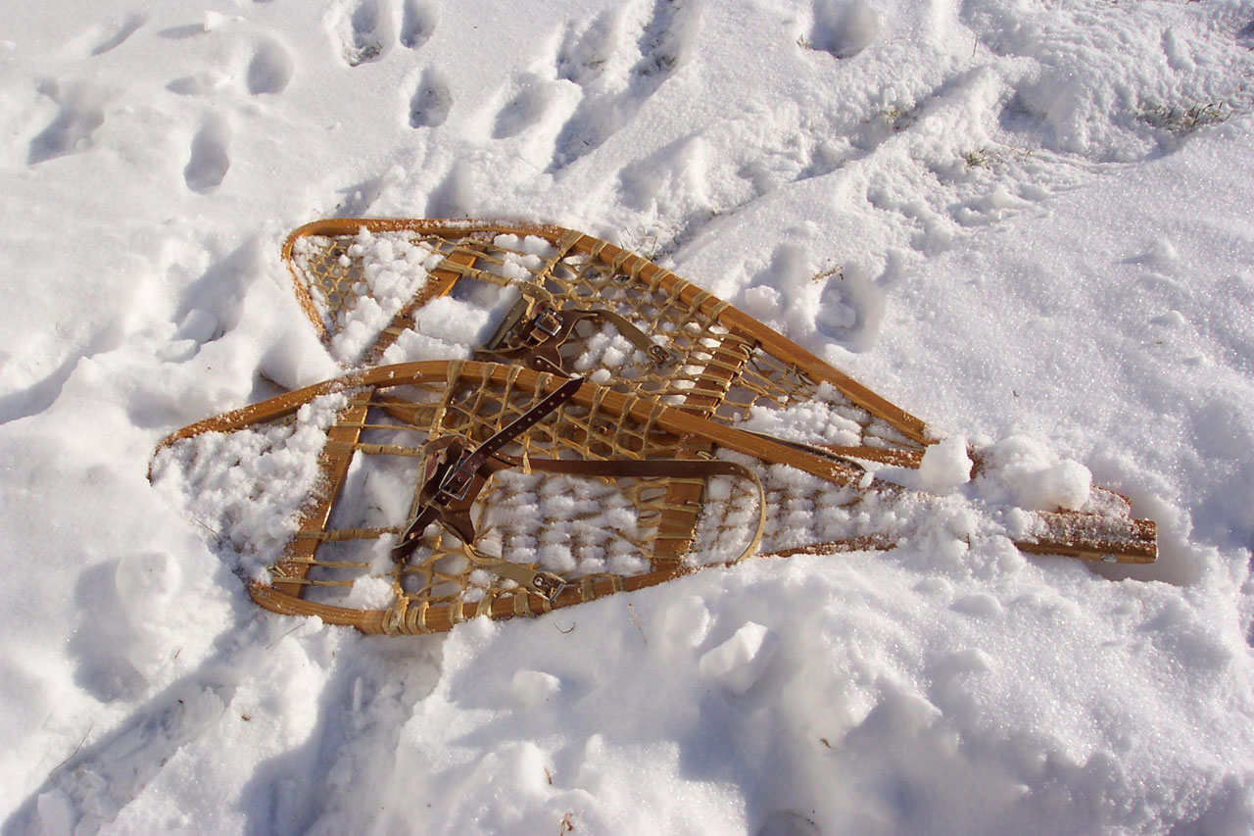 | Snoogie Chicken Rice, broccoli, bread, & fruit | Macaroni Casserole, green beans, pickled beets, & fruit |  |  |  | 