Senior Meals April Lunch Menu
2023
Sunday | Monday | Tuesday | Wednesday | Thursday | Friday | Saturday
 |  |  |  |  |  | 1
1 % milk available at lunch | Menu subject to change without notice |  |  |  |  | This Photo by Unknown Author is licensed under CC BY-SA
2 | 3 | 4 | 5 | 6 | 7 | 8
 | Cheeseburger Deluxe, pasta salad, Cole slaw, & fruit | Chicken salad Sandwich w/lettuce & tomato, pickle, carrot sticks & fruit | Easter Dinner  Boiled Dinner, ham potatoes, cabbage, carrots, turnip, & dessert | Easter Dinner Leftovers | Take home meal.  Chicken Patty Sandwich, French fries, corn, & fruit
9 | 10 | 11 | 12 | 13 | 14 | 15
 | Hot hamburger Sandwich w/gravy, spinach, & fruit | Spaghetti w/meatballs. Veggies in dill dressing, bread stick & fruit | Taco Salad, Bread, & fruit | Oven baked scrambled eggs, sausage, beans, & yogurt | Take home meal.  Tuna Sandwich, chips, carrot sticks, & fruit
16 | 17 | 18 | 19 | 20 | 21 | 22
 | Chicken stir fry, rice, & fruit | Pork Chops, Au gratin potatoes, broccoli, & fruit | Chef Salad, bread, & fruit | Kielbasa w/peppers, rice, broccoli, & fruit | Take home meal.  Sloppy joes, tater tots, corn, & fruit | This Photo by Unknown Author is licensed under CC BY-NC-ND
23 | 24 | 25 | 26 | 27 | 28 | 29
 | Pineapple teriyaki meatballs, rice, green beans, & fruit | Cajun Chicken Pasta, veggies in dill dressing, & fruit | Ham & Cheese Italian, Cole Slaw, chips, & yogurt | Pulled pork, noodles w/alfredo, broccoli, & fruit | Take home meal.  Meatloaf, au gratin potatoes, corn & fruit | 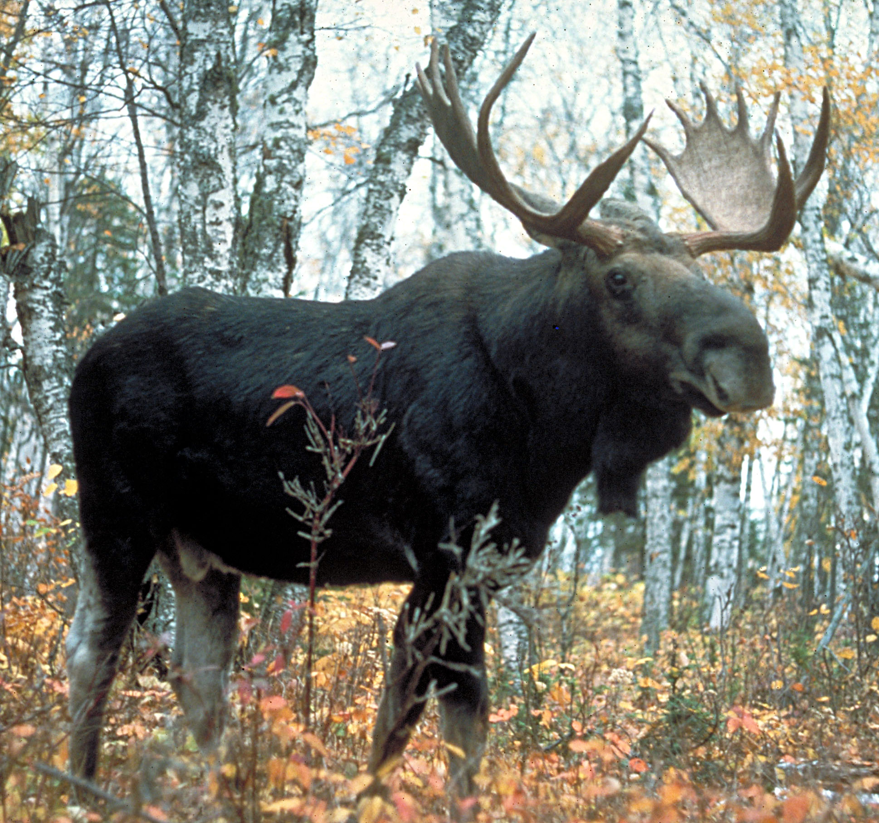
30
 | S | P | R | I | N | G

